
 | Situation  The problem we are trying to solve: This initiative aims to expedite the ED patient arrival process so that we can improve the patient experience and reduce delays in patients receiving care.
 | Background  Of all the questions on our Press Ganey ED patient experience survey, patients respond with the lowest ratings when it comes to feedback on the ED arrival process. We aim to address these patient concerns and improve these ratings through this initiative.
 | Assessment  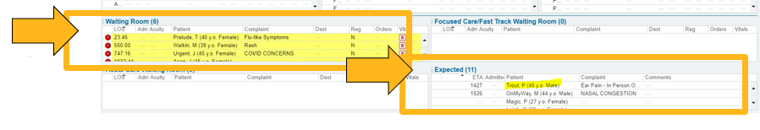  What we are changing: Using On My Way, ED patients will now have the ability, through Sentara.com, MyChart and Google listing links to see local ED wait times and pre-register for a Sentara ED visit. Our team will see the Expected patient on the Epic ED Trackboard. When patients arrive in the ED, using the Welcome tablet, they will be able to enter their registration information into 1 of 4 tablets in the waiting area. Access to Welcome tablets will expedite the process, maintain privacy of the information being provided and allow patients to elect to receive text messages about their visit progress.
 | Recommendation  The SNGH ED is the last phase of On My Way and the Welcome Tablet. Go-Live is scheduled for 12/16/2025. Please direct all patients with non-life threatening emergencies to self-register on the tablet. During the Go-Live, there will be team members available to assist patients if they need assistance and will provide education to the team so they will be able to direct patients moving forward after the Go-Live week.  